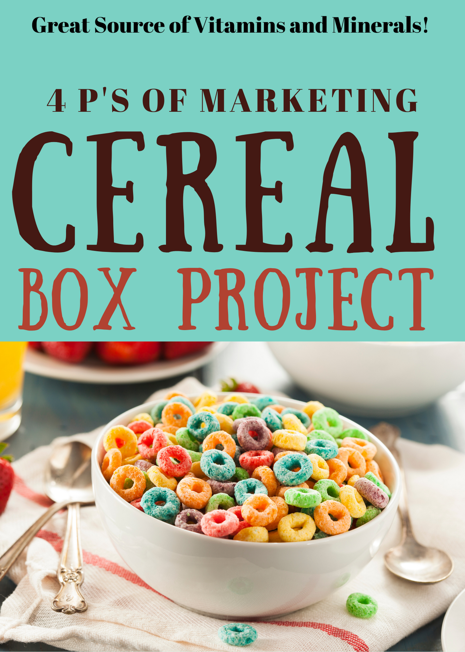

The Marketing Mix
Cereal Box Project
Learning Target: I understand the process for developing, design and promoting a brand
Success Criteria: I successfully worked as a team to create a cereal brand for a specific target market.
Assignment
You have just been employed by a major manufacturer of nutritious and delicious breakfast cereals. Your first assignment is to work with a team that has been given the responsibility of developing a brand new cold breakfast cereal. You will use the 4ps of marketing for your project. Your team will be provided with the target market (see list provided) for this new cereal, and you must come up with the:
- Product:
  - Product idea
  - Packaging (your team will create a prototype of the product)
  - Brand name, brand mark, trade name, trade character
  - Label information (net weight, nutrition, ingredients, size, vitamins, minerals….)
  - 5) Illustrations and promotional offer
Once you have developed your new cereal, you will be trying to sell your company CEO (the instructor) and stockholders (the class) on your new, delicious breakfast food. In this oral presentation your team will: 1) describe your target market, 2) describe your new cereal, including special features and premiums, 3) show your package and point out it’s important features, including logo and trademark, ingredients, nutritional information, etc., and 4) present this information in a Canva Presentation format.
This is a TEAM effort and it will require each member to complete a specific part of the project. Each team member will get “team points” for the overall project and presentation, as well as “individual points” for their specific assignments.
The following activities will give you all the information you will need to successfully complete this important assignment. You should have plenty of time to work on this project (including class time), but don’t procrastinate. You will be expected to produce a quality product and give a professional presentation. Make sure that all aspects of your new product are well coordinated and appeal to your target market.
One Last Note
Just so there is no confusion, let me clarify the group role in the above-mentioned areas. Even though each person is appointed “manager” of an activity, each team member is expected to contribute any ideas or assistance that is needed for each area. This is a TEAM effort and your ultimate grade on the project will reflect on each of the areas. Your product presentation will be no better than the weakest of the four areas. In other words, it is to your advantage to make sure that the package design, market research, and the label are well thought out and professionally done.

The Cereal Project
Team Assignment Descriptions
Each member of your cereal project team will be a “manager” over a specific aspect of the project. The areas of responsibility are: 1. Project manager, 2. Package Manager, Promotions Manager, Presentation Manager. In addition, each team member will be expected to contribute to joint decisions, including brand name, trademark, slogan, product composition, warranty, etc.
Part 1: Product Design:

What is the name of the cereal, how will you brand it, package it, and create a logo design. What character will you use.

The product part of your cereal entails creating a new cereal brand, designing the package that will contain your cereal. The package should include: the brand name, logo, and artwork. You will also need to include something for the back panel, such as a game, promotion, activity, etc. If your cereal includes a premium (gift inside), you will need to include a prototype of the prize as well. In addition, you will include nutritional information and ingredients based on the type of cereal you are creating, you may borrow your labels from an existing cereal brand that is similar to what you are creating (we copy this as we don’t know those details for this project).
We will create our design by using canva template for a cereal box linked in google classroom. We will print these out on construction paper and fold them into a cereal box shape for display. Be sure to include:
- Complete product label
- Brand name
- Logo (one person assigned to create this)
- Trade character (one person assigned to create this)
- Illustrations (one person assigned to create this)
- Promotional offer or free gift in the box (one person assigned to create this)
- …and anything else you feel is appropriate.
- What sizes of Boxes will you create, one or more?

Part 2: Create a Presentation for the 4 Ps of Marketing:

 | Pts | Score
Created a Cereal Box Model that was creative and visually appealing that is created to the market you choose to target that will buy your product. Your design includes  - Selected a theme for your cereal  - Graphics and a character that fits the target market  - Box Coloring and design  - brand name  - Logo and Slogan  - Ingredients and nutritional label | 20
Presentation Points: | 0
Describe the target market you designed your cereal for and include a picture/ graphic of your target market | 5
Product – describe your product and the ideas you used to create your product design and share your model with the class describing the decision for the Product Piece of the Marketing Mix | 10
Place: List of Places where you will sell your cereal | 10
Price: What prices will you charge for your cereal based on the sizes you sell. Find the different sizes available by using google. Or go to the local supermarket and see what they sell.  Also, get the price of cereal in your local market for each size. Write down the regular retail price (not sale price). The retail is what consumers pay for a box of cereal.  Because you are a producer, you sell the cereal to the grocery store for less than they sell it to consumers. Normally grocery stores markup cereal about 40%. That means 40% of the retail profit and 60% of the retail price is cost. So, if cereal sells retail for $3.00, that means the grocery store paid about $1.80 a box. $3.00 X 60% = $1.80. That means you, the producer of the cereal, sold this to the grocery store for $1.80 per box.  You do the math. Fill out based on the different sizes you will sell. Google current pricing for cereal and box sizes.  Size Retail What your Cost to sell it  Size Retail What your Cost to sell it  Size Retail What your Cost to sell it  Size Retail What your Cost to sell it | 10
Promotion:  Describe several ways you will promote your cereal. Look at the Traditional and Digital ways you could promote this from your notes List several. | 10
Ad Points: Now Take a stab at creating a Social Media ad for Instagram. Go to Canva and select Instagram post. Select a design, use the graphics and colors of the front of your box and create an ad that launches your new Cereal. Be sure to include your brand, your logo, your box of cereal, and a call to action (where to buy it). This is nothing we have covered yet, just something to try. Download it as a .jpg and upload your jpg into your presentation so you can show your ad in the presentation. | 10
Presentation – All members of your team presented the product | 10
Listen and Asked appropriate questions during other group presentations. Use of phones, talking, or disrespectful comments are automatic zero on this section. | 15
Total Score | 100
Target Market Characteristics
Target Market #1
This target market is made up of girls ages three to eight from middle to upper class families. These girls love to be girls. They like to dress up, play with their toys, watch cartoons, and are into anything Disney. Their parents make the buying decisions about breakfast cereal based on what their kids want. At the same time, the parents want a cereal that is nutritious, yet fun for the kids.
Target Market #2
This target market is made up of boys ages three to eight from middle to upper class families. These boys love to be boys. They like to play sports and video games, watch cartoons, and are in to toy cars, trucks, and action figures. Their parents make the buying decisions about breakfast cereal based on what their kids want. At the same time, the parents want a cereal that is nutritious, yet fun for the kids.
Target Market #3
This target market is made up of children (both sexes) ages eight to thirteen from middle to upper class families. These kids are starting to make decisions on their own about what they want. They are starting to become independent and want to be “grown up.” They look to teenagers as their role models, love popular music, and are influenced by actors and musicians. Their parents still make the ultimate decision about breakfast cereal as well as other groceries. Their parents are concerned that the children are growing up too fast, and want nutritious foods for them.
Target Market #4
This target market is made up of people that are diet conscious, mostly women but some men too, ages 17 to 42. They are usually in a high income bracket and are willing to spend money on things that are good for them and can help them stay (or get) fit and trim. They want a cereal that is low in calories but high in nutrition and is easy to eat since they are very active, on the run type people.
Target Market #5
This target market is made up of serious athletes, men and women, who want to be in top shape. They are 16 to 38 years of age and are middle to upper class. They enjoy weightlifting and working out and are careful about what they eat. They want to build muscle and body mass and like things with a lot of vitamins and protein. They are willing to spend more for a product they think will benefit them physically.
Target Market #6
This target market is made up of older people ages 55 and up. Many are retired so they may be living a reduced for fixed income. Price is an important consideration in any purchase decision - they want to know they are getting their money’s worth. This market wants a nutritious cereal that is healthy, has vitamins and fiber (to keep them regular), and is easy to digest. Some of the members of this target market are active and exercise regularly; the others know that they should.

